 | FALL CONFERENCE  November 7th-8th, 2014  “Ignite the Spirit!”  INDIVIDUAL REGISTRATION FORM | 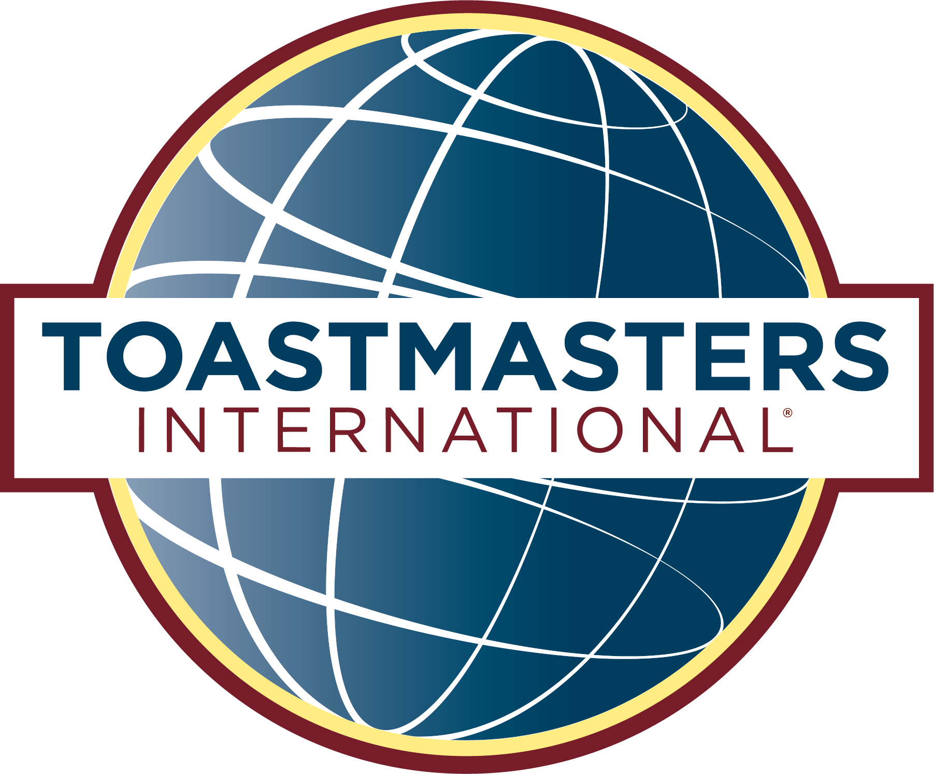

HOTEL INFORMATION

Chula Vista Resort

2501 River Road, Wisconsin Dells, WI 53965

Reservations: 888-965-5837 - Mention “Toastmasters, ID# C60756” for a rate of $99 (single) or $199 (family suite)

Deadline for guaranteed room availability is October 22, 2014

REGISTRANT’S INFORMATION (one person per form please)
PLEASE PRINT CLEARLY
___ Toastmaster or ___ Spouse/Guest ___ First time Toastmaster Conference attendee

Last Name _________________________ First Name ________________________ Designation (CC, CL etc.) ____________

Street Address __________________________________ City __________________________ State _______ Zip _________

Phone: Day_________________ Night _________________ E-mail Address _______________________________________

Your Club # ___________ Name ________________________Office Held: Club___________________________ District____

REGISTRATION FEES

Registration (includes entire conference & Speech Contest; excludes meals & lodging) | Cost | Amount Due
Club Fee - allows 2 or more club members to attend (circle “$70.00” if fee has been paid) | $70.00 | Paid by Club
Or individual fee – (no club registration) | $40.00
Saturday Luncheon | Meals - indicate choice by entering amount due in corresponding box
Honey Glazed Chicken – served at Chula Vista for over 60 years | $20.00
Roast Pork with Apple Bread Stuffing | $20.00
Baked New England Haddock Asiago Provencal | $20.00
Special Dietary Needs (list here):
Saturday Dinner Banquet | Meals - indicate choice by entering amount due in corresponding box
Sliced Sirloin Bordelaise – layered with a smooth mushroom Au Jus | $30.00
Roast Pork and Garlic Mashed Potatoes – with pan gravy | $30.00
Roast Sliced Turkey – on a bed of Apple Bread Stuffing | $30.00
Special Dietary Needs (list here):
►Reservation deadline: October 10, 2014. No refunds for cancellations after October 24 | TOTAL

MAILING INFORMATION
Please mail your completed form and check made payable to District 35 Toastmasters to:
(Multiple forms per check allowed)
Rhonda Williams, R5694 Pioneer Rd., Athens, WI 54411
715.297.3241
Or look for “District 35 Toastmasters Fall Conference – Ignite the Spirit!” on EventBrite @
https://www.eventbrite.com/e/district-35-toastmasters-fall-conference-ignite-the-spirit-tickets-13057861415

