 | FALL CONFERENCE  November 7th – 8th, 2014  “Ignite the Spirit!”  CLUB REGISTRATION FORM | 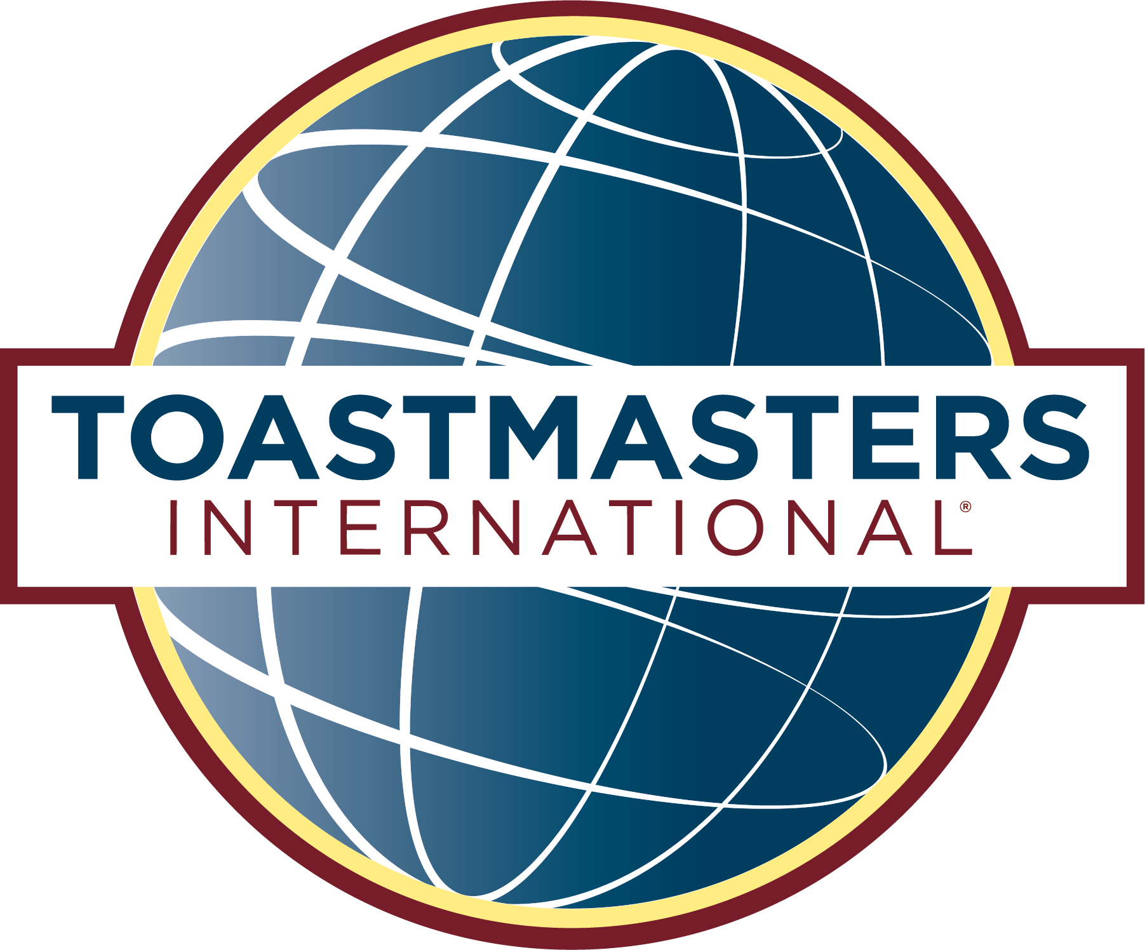

HOTEL INFORMATION

Chula Vista Resort

2501 River Road, Wisconsin Dells, WI 53965

CLUB INFORMATION
PLEASE PRINT CLEARLY

Club # ________________ Club Name _________________________________________________________________

Club Contact_______________________________ Contact Phone_________________________________________

Contact Email_____________________________________________________________________________________

REGISTRATION FEES

Registration (excludes meals & lodging) | Cost
Club Fee – suggested when 2 or more club members to attend the conference | $70.00
►Registration deadline: October 10, 2014  ►No refunds or cancellations after: October 24, 2014 | TOTAL

CONTACT INFORMATION

NOTE: Club members must still send Individual Registrations in order to indicate meal choices and to pay for their meals.

If they choose to forego the banquets, they must still send Individual Registrations to ensure we have an accurate head count, and in order to receive name badges, conference brochures, and goody bags. Registrations at the door will be available on a limited basis, and no meal tickets will be sold at the door.

Please mail your completed form and check made payable to District 35 Toastmasters to:
Rhonda Williams
R5694 Pioneer Rd
Athens, WI 54411
715.297.3241

Or look for “District 35 Toastmasters Fall Conference – Ignite the Spirit!” on EventBrite @
https://www.eventbrite.com/e/district-35-toastmasters-fall-conference-ignite-the-spirit-tickets-13057861415

