
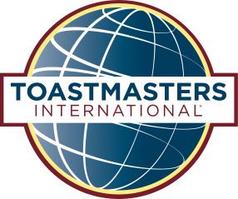
Club Registration Form
District 35 Spring Convention
Solving the Leadership Puzzle
May 6-7, 2016
Best Western Premiere Waterfront Hotel & Convention Center
1 N Main Street Oshkosh, WI 54901
Reservations: 920-230-1900

Clubs must complete and submit this form BEFORE
each attendee submits his/her own Individual Member Registration form

Club Information Please print clearly
Club # ____________ Club Name _________________________________________________________
Club Contact____________________________ Contact Phone________________________________
Contact Email__________________________________________________________________________
Registration Fees

Registration (excludes meals & lodging) | Cost
Club Fee  Suggested when 2 or more club members attend the conference | Postmarked on or before 04/23/16 | Postmarked between 04/24 & 04/30/16
 | $80.00 | $90.00
►Club registration deadline: April 30, 2016 | TOTAL
Club members must still send Individual Registration forms to indicate meal choices and pay for
their meals.

Important: If attendees choose to forego the banquets, a club or individual registration fee is
still required along with an Individual Registration form. Individual Registration forms ensure we
have an accurate head count for name badges and conference brochures.

Walk-in registration will be available, but club or individual registration fees must be paid.
Walk-in registrations will not include meals or brochures.

Please mail your completed form and check made payable to District 35 Toastmasters to:
Katie Adams
919 S Matthias St Appleton, WI 54915
920-268-2658 katie.thiel@snc.edu
Or look for “District 35 Toastmasters Spring Convention” on EventBrite @
https://www.eventbrite.com/e/district-35-spring-convention-solving-the-leadership-puzzle-tickets-23069538611

