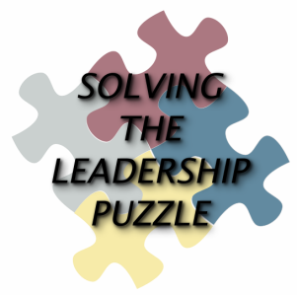
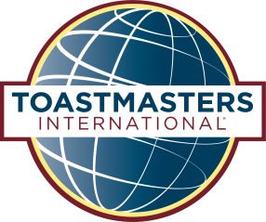
District 35 Spring Convention
Solving the Leadership Puzzle
May 6-7, 2016
Best Western Premiere Waterfront Hotel & Convention Center
1 N Main Street Oshkosh, WI 54901 Reservations: 920-230-1900
Mention “Toastmasters” for a rate of $92.99 (single or double)
Deadline for guaranteed room availability is April 16, 2016
Online registration link below in blue box
Registrant’s Information One person per form please
I am a Toastmaster _____ or Spouse/Guest ________ This is my first District 35 Conference/Convention _______
Last Name _________________________First Name _____________________ Designation (CC, CL etc.) ____________

Street Address ______________________________ City __________________________ State _______ Zip _________

Phone ________________________________ E-mail Address ______________________________________________

Home Club # ____________ and/or Club Name _______________________Club Office Held (current)________________
Fees
Club and Individual fees You will receive email confirmation of your payment
Check here if your club is paying the club registration fee ______
To verify if your club has signed up, refer to the District 35 website page, 2016 Spring Convention.
Check here if you are paying the individual registration fee and circle the appropriate fee below ______
Postmarked on or before 04/23 $50 Postmarked between 04/24 & 04/30 $55

Post-marked on or before 4/23 | Post-marked between 4/24 & 4/30
$50.00 | $55.00
$20.00 | $23.00
$20.00 | $23.00
$20.00 | $23.00
$35.00 | $38.00
$35.00 | $38.00
$35.00 | $38.00
Meal Options
See menu details on page 2
Discount! If attending lunch AND dinner, circle meal selections below and pay this amount
OR
Circle meal options below and pay corresponding amount
Lunch
Lemon-Herb Baked Tilapia (gluten free)
Classic Meat Lasagna
Stuffed Red Peppers (vegetarian/gluten free)

Dinner
Chicken Piccata
Italian Beef Braciole
Wasatch Pie (vegetarian/gluten free)

Total amount submitted (including circled individual fee and meal selection): $_________
Please mail your completed form(s) and check payable to District 35 Toastmasters (multiple forms per check allowed) to: Katie Adams 919 S. Matthias St. Appleton, WI 54915 (920) 268-2658 katie.thiel@snc.edu
Online Registration: Look for “District 35 Toastmasters Spring Convention” on EventBrite @
https://www.eventbrite.com/e/district-35-spring-convention-solving-the-leadership-puzzle-tickets-23069538611

https://www.eventbrite.com/e/district-35-spring-convention-solving-the-leadership-puzzle-tickets-23069538611

Registration blackout dates: No advanced registration post-marked after 05/01 accepted.
Walk in registration is available for $55. It does not include meals or brochures. No refunds after 04/30/16.
District 35 Spring Convention
Solving the Leadership Puzzle
May 6-7, 2016

Menu Details

Saturday Luncheon – Lunch includes tossed garden salad with house dressings, dinner rolls and butter

Lemon-Herb Baked Tilapia | Tilapia with wild rice blend with green beans (gluten free)
Classic Meat Lasagna | Lasagna with fresh Italian vegetable blend
Stuffed Red Peppers | Red peppers stuffed with fresh burrata cheese, fresh basil, leek frittes and caramelized balsamic onion jam served over saffron risotto and fresh chives (vegetarian /gluten free)

Saturday Dinner Banquet – Dinner includes tossed garden salad with house dressings, dinner rolls
and butter

Chicken Picatta | Marinated chicken breast with sautéed mushrooms, fresh lemon and sherry sauce, served with herb smashed potatoes and green beans
Italian Beef Braciole | Tender beef flanks stuffed with spinach, garlic and roasted peppers, slow braised in rich tomato sauce and served with risotto milanese
Wasatch Pie | Portobello mushroom cap rubbed with chipotle infused olive oil, packed with flame roasted black beans, zucchini, corn and sweet peppers topped with creamy gorgonzola and served with basmati rice (vegetarian/ gluten free)

Please mail your completed form(s) and check payable to District 35 Toastmasters (multiple forms per check
allowed) to:

Katie Adams
919 S. Matthias St. Appleton, WI 54915
(920) 268-2658
katie.thiel@snc.edu

Or look for “District 35 Toastmasters Spring Convention” on EventBrite @
https://www.eventbrite.com/e/district-35-spring-convention-solving-the-leadership-puzzle-tickets-23069538611

https://www.eventbrite.com/e/district-35-spring-convention-solving-the-leadership-puzzle-tickets-23069538611

Registration blackout dates: No advanced registration post-marked after 05/01 accepted.
Walk in registration is available for $55. It does not include meals or brochures. No refunds after 04/30/16.

