Instructions for recording club officer training
- From Toastmasters.org, logon as usual and proceed to Leadership Central > District Central > District 35. From there you will be able to conduct district business (see below)
- Select Record/review club officer training
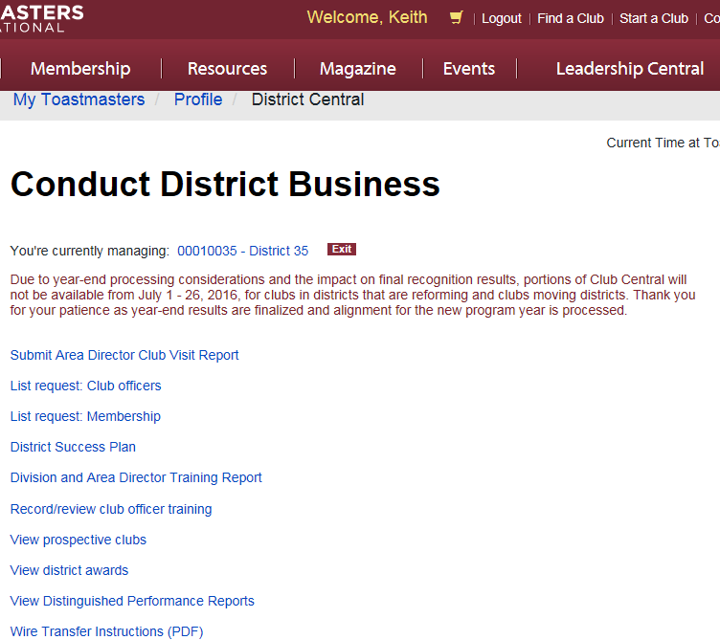
- See the club/officer matrix (below) and check off those officers who have attended training. Note, as of today (June 26), Toastmasters International has not reconfigured the clubs into the new Divisions and Areas … this is likely to change at any time. At any time you may click “Submit for Processing” to save your work.
- Training must be completed by August 31 and recorded by November 30 (although we would prefer you record attendance soon after the training has occurred.
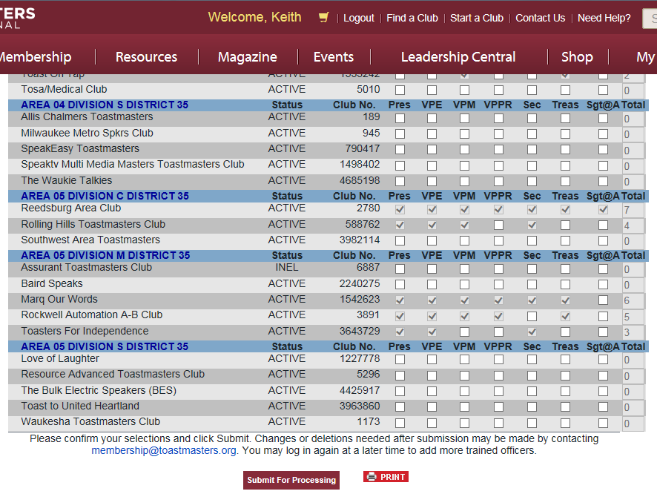
- You may record training of a club officer from within District 35, but outside of your Division. If a club officer from outside of District attends your TLI, contact the Program Quality Director of the appropriate District (most Districts have up-to-date contact information on their websites).
- Any questions, contact your Program Quality Director, Keith Cumiskey.

