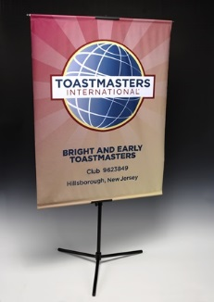
Banner replacement program
Toastmasters International introduced the current logo in 2011. Some of our clubs have proudly retained their clubs banners with the previous logo. However, the time has come to embrace the current branding. We would like every club in the District to have a club banner with the current logo.
If your club meets the requirements for the Distinguished Club Program (DCP) by March 17, 2017, the District will provide you a new banner and banner stand. Your new banner will be presented to you at the Spring Convention. If your club becomes Distinguished by June 1, 2017, the District will provide you a new banner which will be delivered to you by your area director.
We hope you keep your old banners with the ribbons representing proud accomplishments of your club and members. Feel free to bring them along to the Spring Convention in Marshfield. However, beginning with the Spring Convention (May 2017), every club represented in the Parade of Banners must have a banner with the new logo.
Has your club misplaced its banner (old or new logo)? You are eligible for this same incentive.
Contact Program Quality Director, Keith Cumiskey with any questions.

