Education session descriptions

Dick Hawley, DTM
Dick Hawley, DTM has been a Toastmaster since 1981 when he joined as a charter member of the Sentry Toastmasters Club. He is a past Distinguished District Governor and a past International Director. Dick is currently serving as the N1 Area Director.

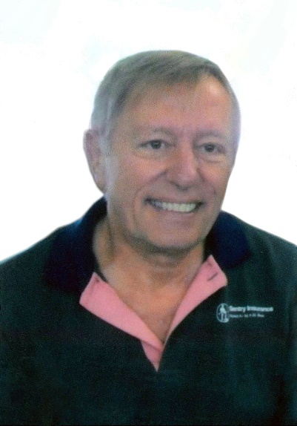

Judy Bauer, DTM and Sierk Oudemans, DTM
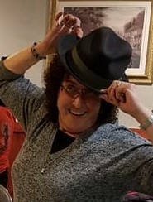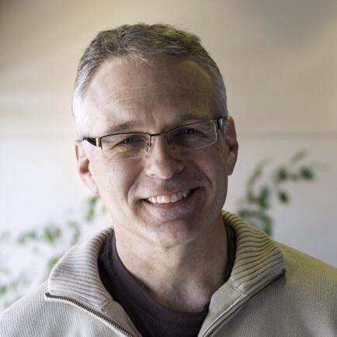
Judy Bauer has been a member for 26 years, she is a DTM, PDG, current D35 Club Coach Chair and a Pathways Guide.
Sierk Oudemanns has been a member for 19 years, he is a DTM, Past AD and a current Pathways Ambassador.

George Gesior, CC and Aliucha Ramos
Aliucha Ramos is a multilingual certified professional coach and group facilitator with 18 years of leadership experience as a global marketing executive. As a leadership coach, she has been guiding leaders to enhance their emotional intelligence, their sense of empowerment, and to adapt their style.

George Gesior is a member of Advanced Leadership Toastmasters Club, recently completing his CC. George is a founder of Positive Force LLC, focusing on mentoring and consulting in Artificial Intelligence. He has worked for GE, Rockwell, and Brog-Warner, and holds four patents and a master’s degree.

Note: This will be updated…the PDF cutoff the last few words in their bios, but wanted to get the placeholder to you ASAP.

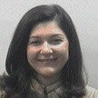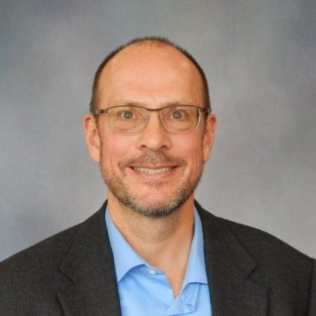

Diane Rose Bolash, DTM
Diane Rose Bolash speaks on a variety of topics concerning communication, and is an expert in body language, developed in working with the Deaf community. Through those experiences, she’s learned that EVERY movement has meaning…and every meaning can be enhanced through integrated body language.
