Spring Conference Meeting Agenda
January 8, 2023

7:15pm – 8:30pm Welcome and Introductions Kris & Team
8:30pm – 8:50pm Updates for what’s been done so far Kris, Teri, Jason
Discussion on pricing Jason
8:50pm – 9:00pm Next steps Kris

Meeting Notes
Attendees: Kris Pool, Jason Feucht, Teri McGregor, Ronda Borowski
Team Members (invited to attend):
Conference Chair | Kris Pool
Program Quality Director | Jason Feucht
Finance Manager | Paul Freiberg
Facilities / Logistics | OPEN
Registration | Ronda Borowski
Public Relations | Kat Yets
Website & Social Media | Teri McGregor
Program / Brochure | Tammy Jankowski
Photographers | Craig Carpenter  OPEN  OPEN
First Timers Reception | Joe Barbieri
Technology | Jeff Ebel  Jeff Wuteska
Education Sessions | OPEN
Sponsorships | OPEN
Ads | OPEN
Raffles | OPEN
Emcee | David Gagliano
Chief Judge | Judy Bauer
CC: | Jennifer Kibicho, District Director  Robert Wall, Club Growth Director

Welcome and Introductions
- Each attendee was asked their favorite way to eat eggs, favorite sweet treat or candy, and best way to receive praise or recognition
Updates on Spring Conference Plans
- Teri – shared logo and design work
- Theme is Key to Success
- Color scheme is purple and blue
- Save the Date has been posted on Facebook and Weekly News
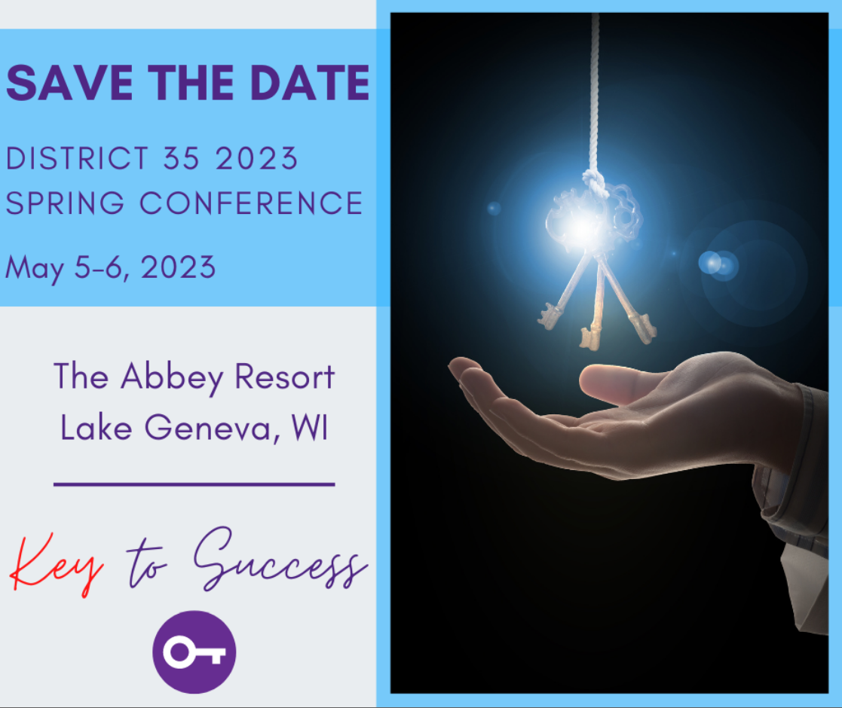
- Call for volunteers has been posted on Facebook and Weekly News
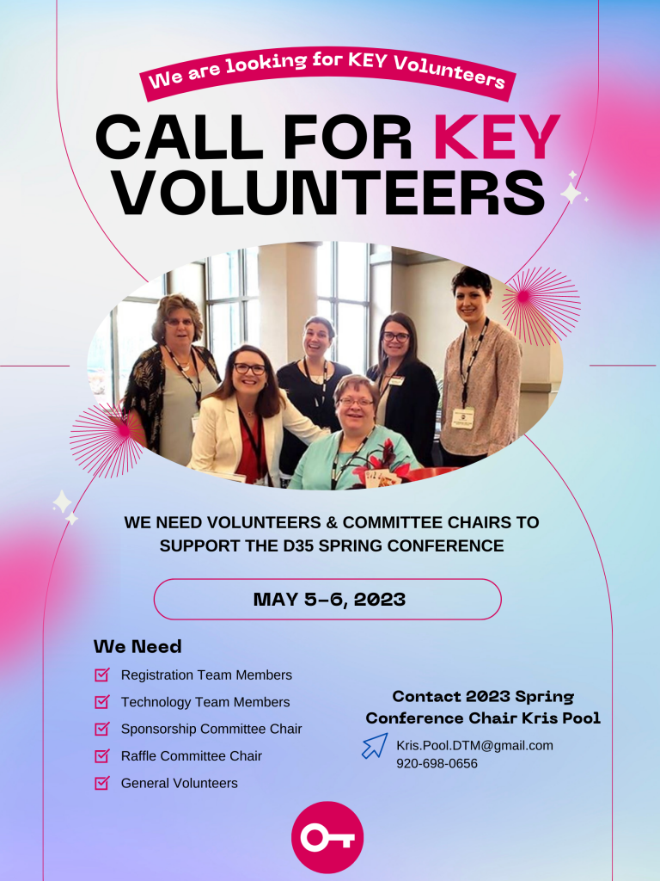
- Hotel room block has been posted on Facebook and Weekly News
  - Room block – 30 rooms booked for Friday, May 5 and 30 for Saturday, May 6
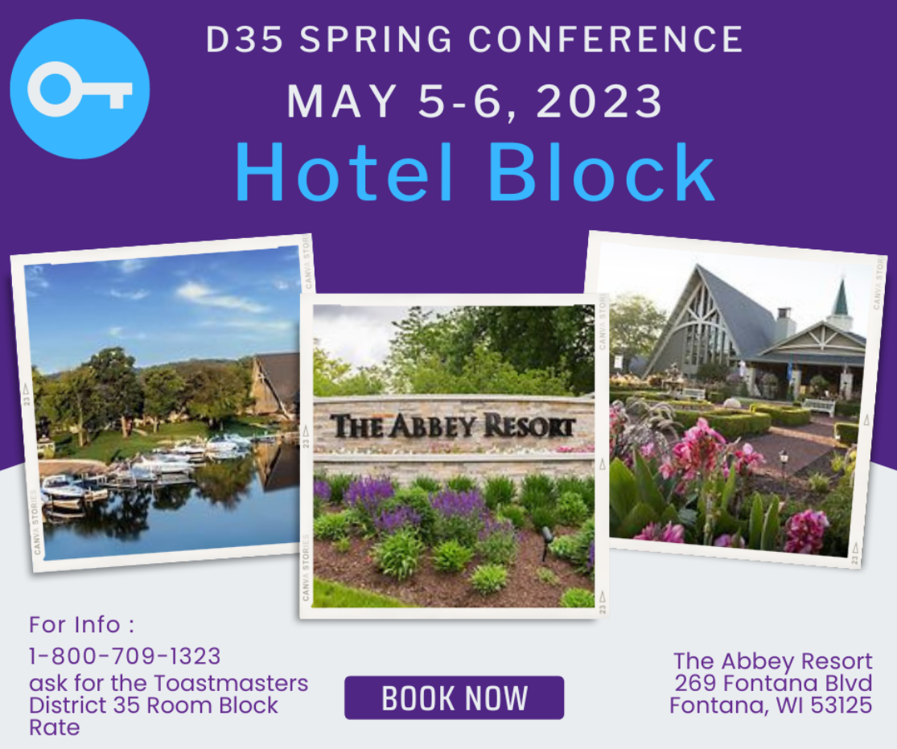
- Updates to the district website are being worked on; the Spring Conference information will be a separate page on the www.district35.org website – no separate website which may get confusing
- The “KEY” is an acronym for several different phrases
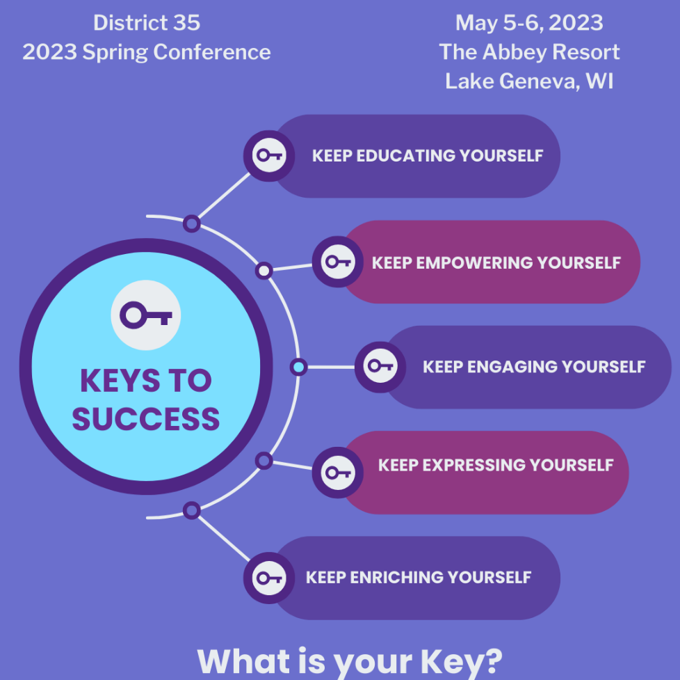

- Speakers
  - Virtual education sessions on Sunday, April 30 – Wednesday, May 3
    - Sunday – Jim Key (waiting for confirmation)
    - Monday – Cindy Laatsch – Strength Finders (waiting for details)
    - Tuesday – Valda Ford
    - Wednesday – Jim Emergy – Vocal Delivery on Steroids
  - Thursday, May 4 – possible virtual judges and contestant briefing (with a short in-person briefing prior to the contact at The Abbey)
  - Live education sessions on Friday, May 5 and Saturday, May 6
    - Friday – Marty Jalove – The Art of Small Talk
    - Saturday – Mary Jalove – Storytelling When Speaking
    - Saturday – Andy Little – Let’s Build the Excitement
    - Saturday – TBD
    - Saturday – TBD
  - Keynote speaker – International Director Region 5 Monnica Rose
- Call for speakers
  - Waiting for additional submissions from:
    - Chad Lawson
    - Kimberly Hall
    - Tina Boyle White
    - Marcy Heim
- Tentative Schedule Overview
  - Friday, May 5
1:00-3:30 | Vision Boards - TENTATIVE
3:30-7:00 | Registration  Raffles
4:00-4:45 | Marty Jalove – The Art of Small Talk
4:45-10:00 | Cash Bar
5:00-6:30 | PDG/PDD Dinner
5:00-6:00 | First Timers Reception
5:00-7:00 | Networking
6:45-7:05 | Contest Briefing
7:15-8:30 | Tall Tales contest
9:00-10:30 | Friday Fun Night – Campfire Stories & Smores – Dave Schmitt

  - Saturday, May 6
5:30-6:15 | Morning Walk
6:30-7:45 | Breakfast Buffet
7:00-12:00 | Registration
7:00-6:00 | Raffles
8:00-9:45 | Welcome, Opening Ceremony, Keynote by Monnica Rose
10:00-10:45 | Education Session 1 and 2
11:00-11:45 | Education Session 3 and 4
12:00-2:00 | Lunch, Awards, Keynote by Monnica Rose
2:15-2:45 | Contest Briefing
3:00-5:00 | International Speech Contest
5:00-6:00 | Networking
5:30-10:00 | Cash Bar
6:00-8:00 | Dignitary Welcome, Dinner Banquet, Remarks, Installation of incoming officers by Monnica Rose
8:20 | Hall of Fame
8:40 | Raffle Winners announced
9:00-10:00 | Networking, Socializing, Cash Bar

  - Sunday, May 7
9:00-10:30 | Leadership Breakfast – OPTIONAL  Monnica Rose – 15 minutes – inspiration  Invite: Outgoing and Incoming DEC, PDD/PDG, International Directors & Dignitaries

Food
- Food prices will be all-inclusive. It will include Friday snacks and Saturday breakfast, morning break, lunch, afternoon break, and dinner
  - Lunch and dinner will include soup or salad (will be specified on registration form when choosing lunch option) and dessert
- Friday night dinner for PDD/PDG – separate cost but can purchase through Eventbrite
- Sunday breakfast – optional – separate cost but can purchase through Eventbrite
- Prices for everything in general have gone up over the past few years and that will be reflected on the prices given to our membership
- Sponsorship may be a way to decrease the costs – or reimburse to individuals or clubs after the event once we know the sponsorship amounts
- In the past, DEC members would have protocol for pricing at the Spring Conference; due to the costs this year, we cannot comp what we have all done in the past but will offer discounted amounts
- Food options picked are the lowest or second lowest pricing option
- Discussion about a guest price – defining guest as the spouse or significant other of the Toastmasters member
  - Guests are not Toastmasters from other districts; they would pay the member price
- Make a promotional video to explain pricing
Registration
- Jason will take the proposed budget to the Trio for approval; once approved, registration will open in February
- Club registration – if a club registers, that will cut down on the individual cost for members to attend
- One month for early bird pricing and about 1-2 months for regular pricing; hopefully the price difference will encourage clubs and members to register early
- There is a FAQ that is being updated – this would include the refund policy
  - Cancellations before noon on April 25 will be fully refunded minus a $15 processing fee
  - No cancellations after noon on April 25; registration can be transferred to another person (meal selection remains the same)
- Connect with the members of established clubs and members that can influence others, such as Rat Pack, and ask them to help encourage others to attend the Spring Conference in person
- Promotional video to explain registration pricing
  - If club is registered, attending virtual is no charge
  - If club is not registered, attending virtual will be $25
- All education sessions will have their own Zoom meeting link and the main meeting link is separate
- Open registration:
  - Open first week of February for club registration – early bird pricing
  - Open 2nd week of February for individuation registration – early bird pricing
  - March 1 – April 25 – regular registration pricing
  - No walk-in registrations
  - Virtual registrations only between April 25 and April 29.
  - No registration – virtual or otherwise – April 30 through May 6
Other Discussion Items
- Promote the Spring Conference as a family weekend getaway – let the family do their own things while the Toastmaster attends the conference events
- Sponsorship – final edits being made on the sponsorship opportunities information and will be sent to DEC and club officers next week
- Future Spring Conference planning meetings
  - Schedule with individual meeting calendar notices was emailed out
  - All committee members are invited to attend each meeting; those on the agenda for a specific meeting date should definitely be in attendance
  - All committee members should know what’s going on throughout the process and can share ideas
  - Need to develop list of volunteers to help onsite the days of the conference; they don’t need to attend the planning meetings unless if they want
- Central Division the host Division for the Spring Conference
  - Emails sent to Laura Schoenhoer at Walworth County and Charles Elftman and Lee Sampson to head up the volunteer committee since majority of volunteers will likely be more local members
  - Walworth County and Waukesha County Toastmasters Clubs are the closest clubs to the conference facility
- 2024 Spring Conference
  - Jason will send out RFPs in the coming weeks; would like to announce at the 2023 Spring Conference the location of next year’s event.
  - Location will probably be Eastern or DFAB.
  - Will look at flexibility of dates in April and May 2024, but to exclude Mother’s Day weekend; Jason will verify date requirements according to Toastmasters International
  - Jason will look to combine the District Council Meeting as part of the Spring Conference rather than a separate weekend
Next meeting date – Sunday, January 22, 2023 from 7pm to 8pm
- Agenda Items
  - Registration and final costs
  - PR updates
  - Speaker confirmations
  - Timeline and next steps
- If you have anything to add to the agenda, please forward discussion items to Kris Pool

